**DESING TOOLS WORKSHOP – I**

**SEM IN LAB EXAMINATION – I**

**FROM 02-09-2019 TO 07-09-2019**

**QUESTION BANK**

|  |  |  |
| --- | --- | --- |
| **C01** | **C01** | **C02** |
| **15** | **5** | **10** |

**CO1**

**PART 1**

**PART MODELLING IN CREO PARAMETRIC**

1. Draw the front view, top view and side view of the object shown in Fig.

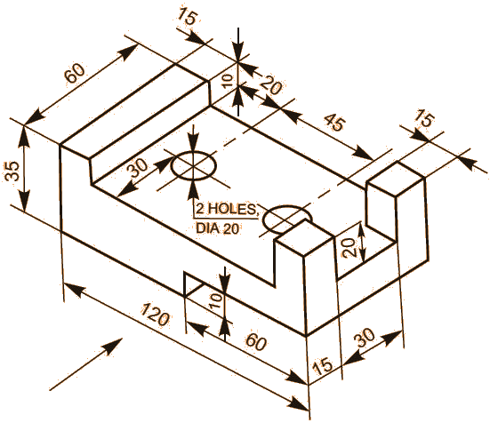

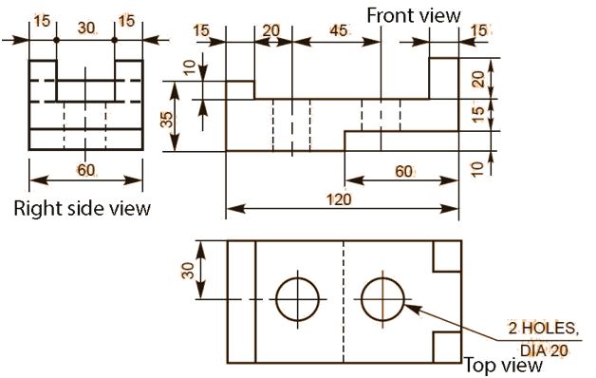

1. Draw the front view, top view and side view of the object shown in Fig.

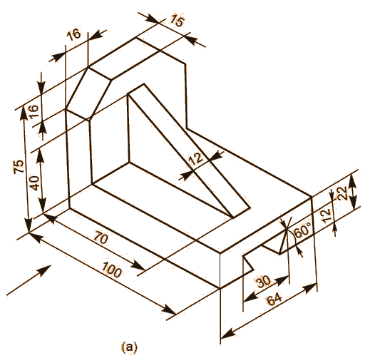

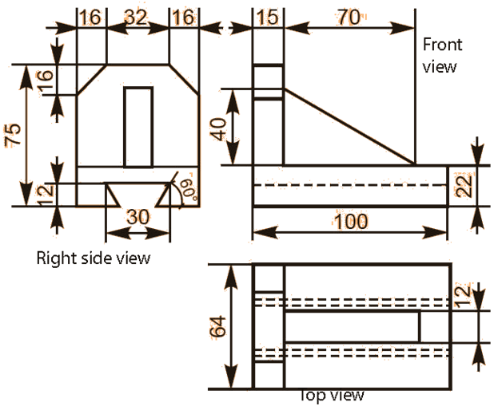

1. Draw the front view, top view and side view of the object shown in Fig.

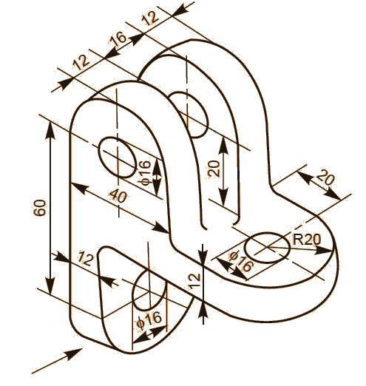

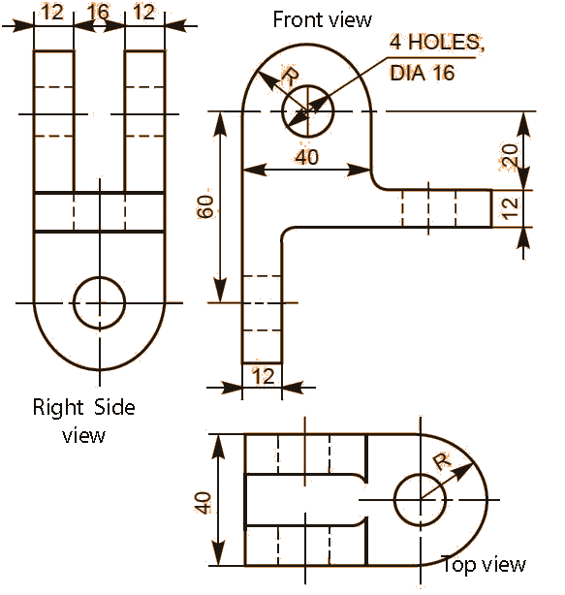

1. Draw the front view, top view and side view of the object shown in Fig.

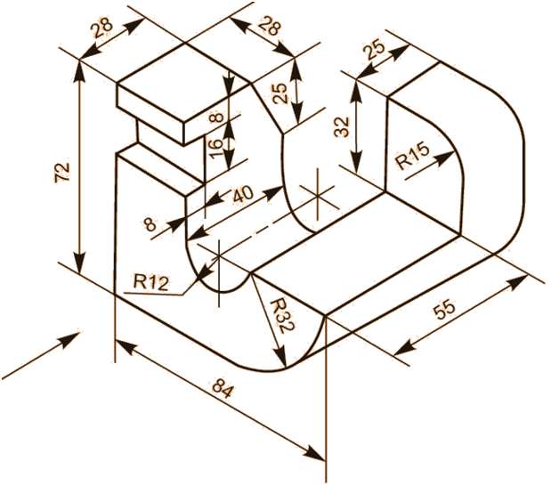

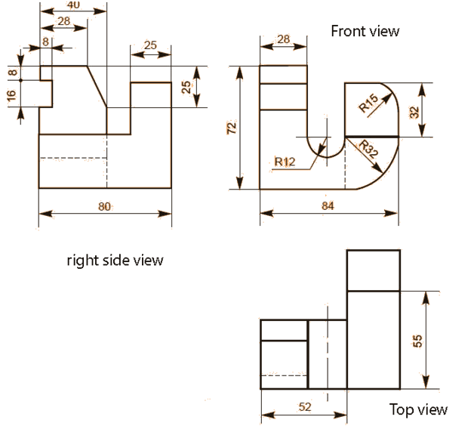

1. Draw the front view, top view and side view of the object shown in Fig.

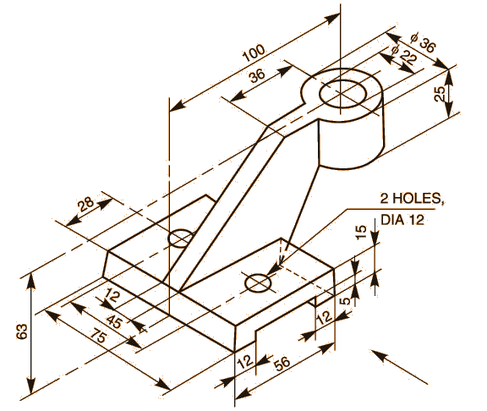

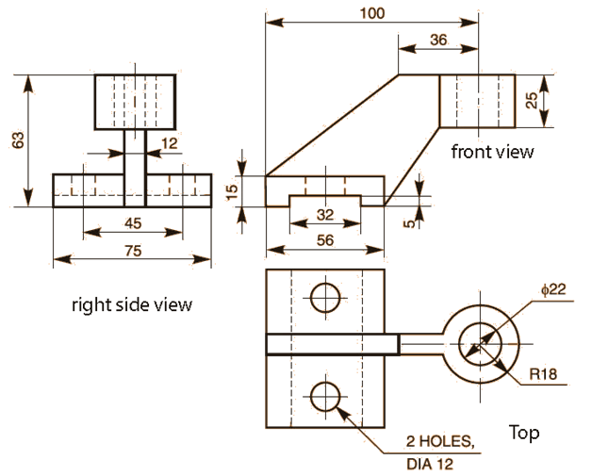

1. Draw the front view, top view and side view of the object shown in Fig.

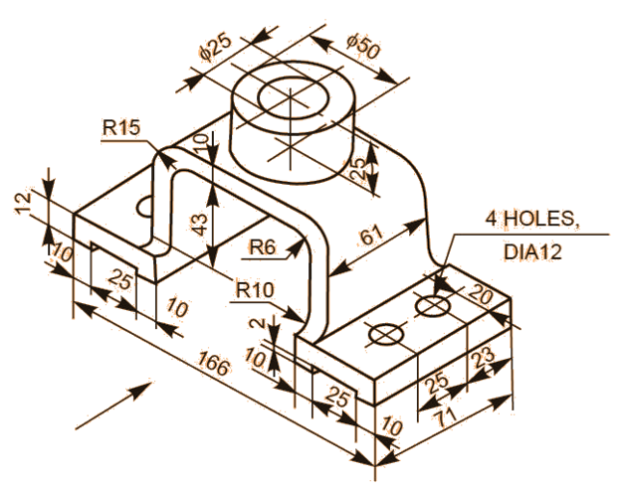

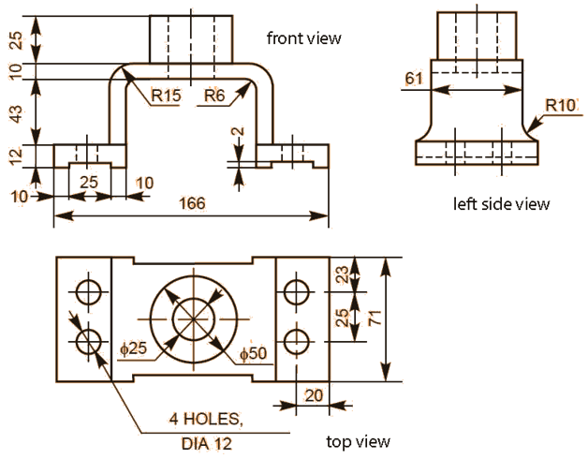

1. Draw the front view, top view and side view of the object shown in Fig.

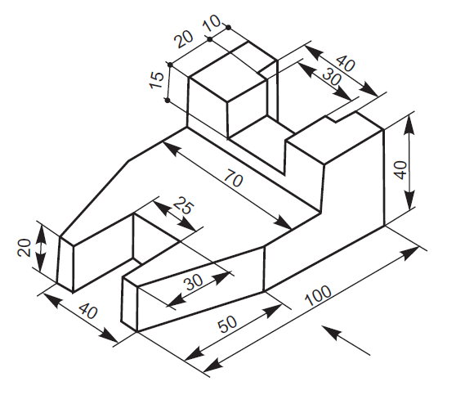

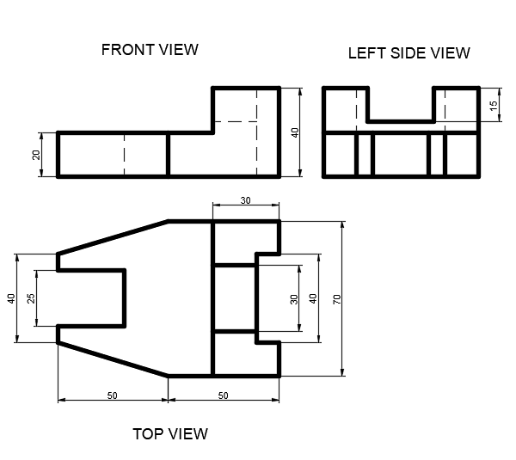

1. Draw the front view, top view and side view of the object shown in Fig.

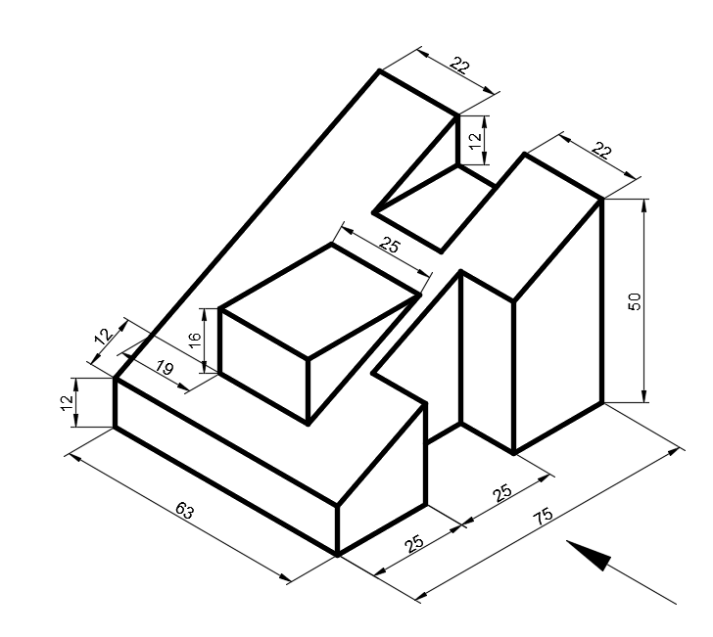

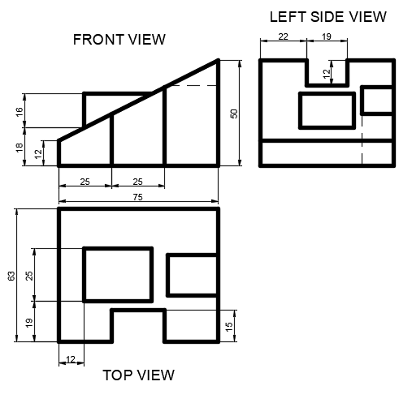

1. 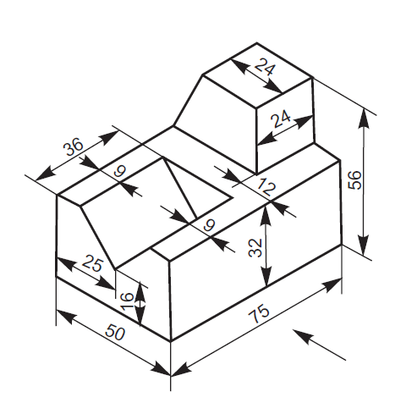Draw the front view, top view and side view of the object shown in Fig.

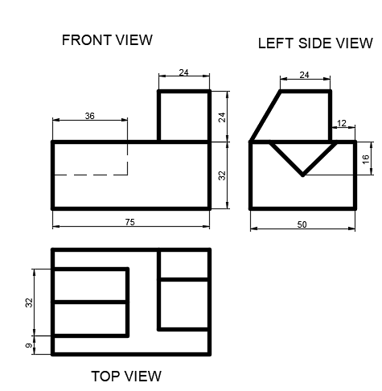

1. 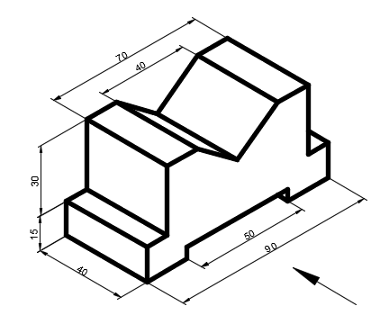Draw the front view, top view and side view of the object shown in Fig.

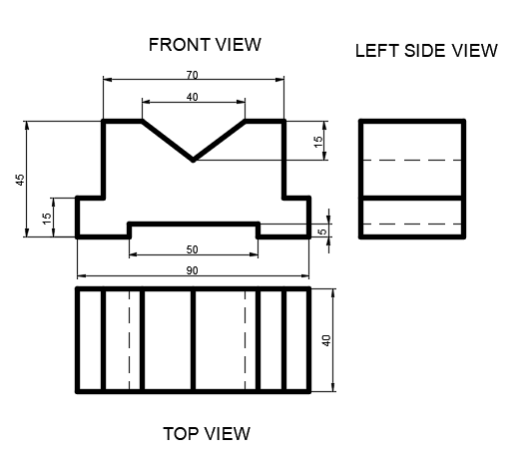

Orthographic question

1. Draw the front view, top view and side view of the object shown in Fig.

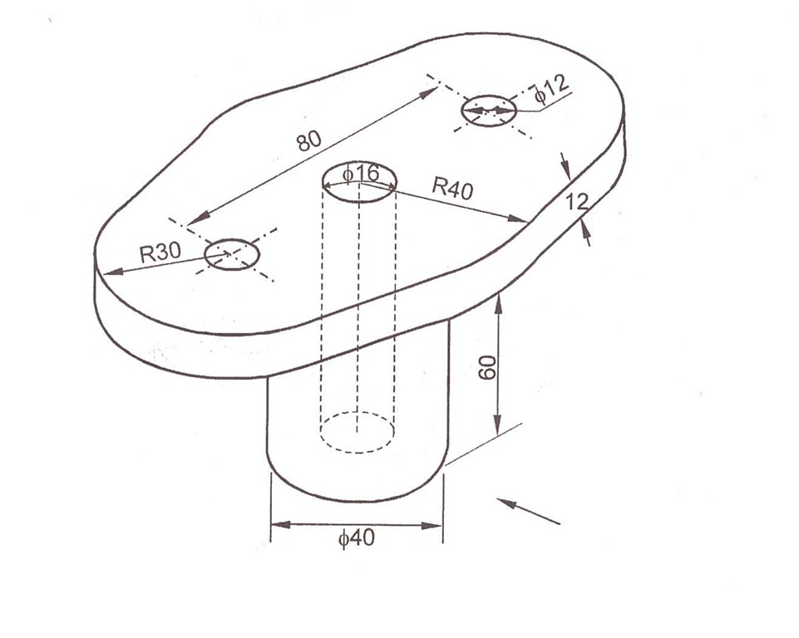

1. Draw the front view, top view and side view of the object shown in Fig.

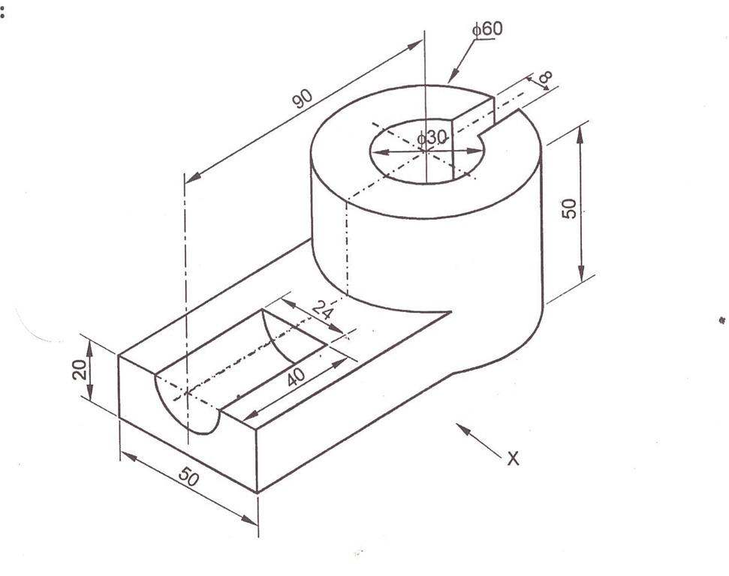

1. Draw the front view, top view and side view of the object shown in Fig.

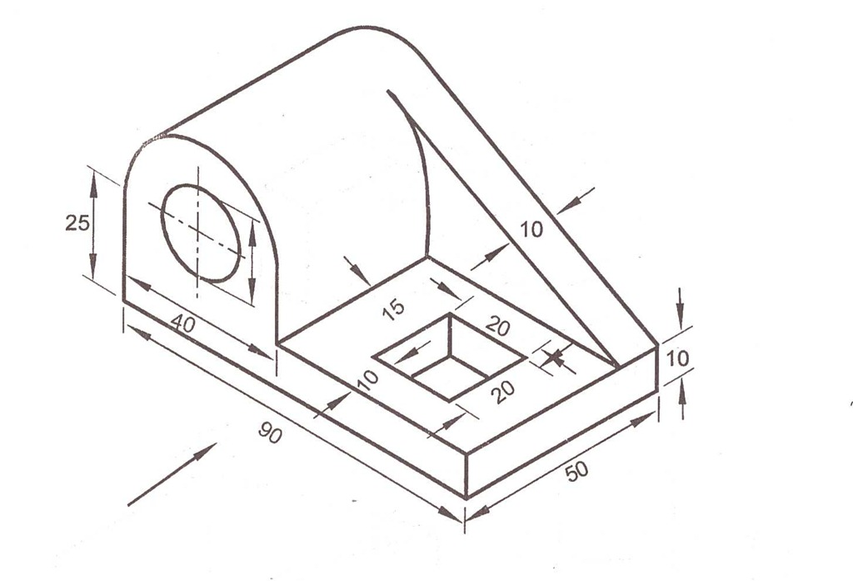

1. Draw the front view, top view and side view of the object shown in Fig.

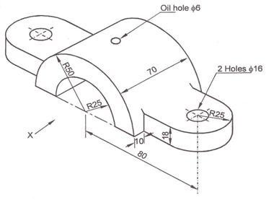

1. Draw the front view, top view and side view of the object shown in Fig

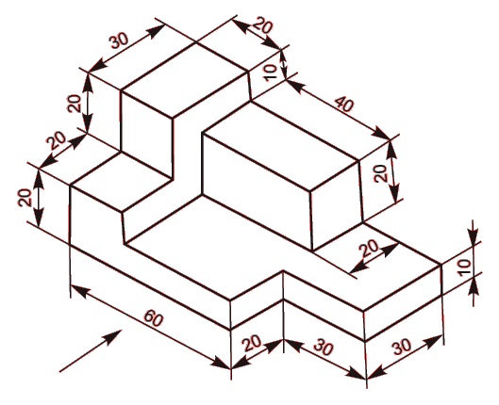

1. Draw the front view, top view and side view of the object shown in Fig

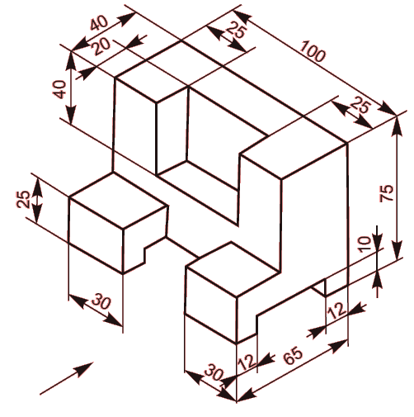

1. **Draw (i) the view from the front, (ii) the view from above and (iii) the view from the right, of the objects shown below:**

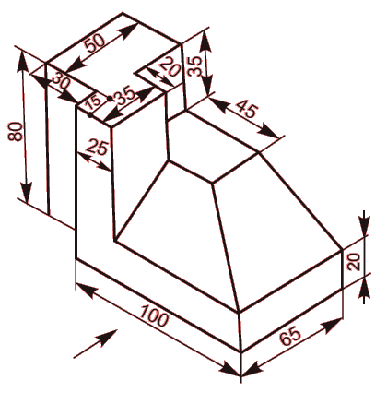

1. **Draw (i) the view from the front, (ii) the view from above and (iii) the view from the right, of the objects shown below:**

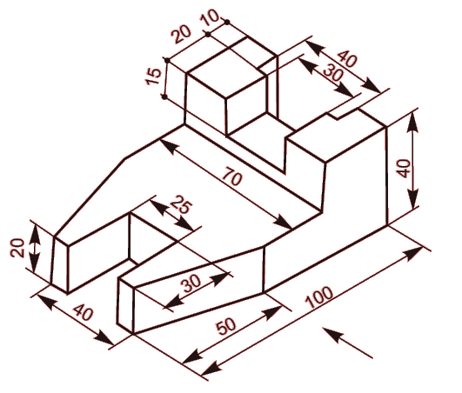

1. **Draw (i) the view from the front, (ii) the view from above and (iii) the view from the right, of the objects shown below:**

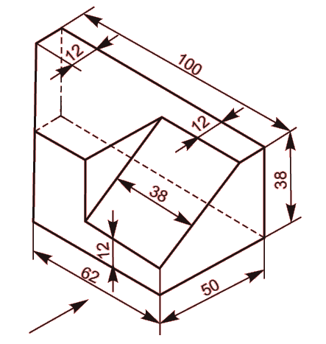

1. **Draw (i) the view from the front, (ii) the view from above and (iii) the view from the right, of the objects shown below:**

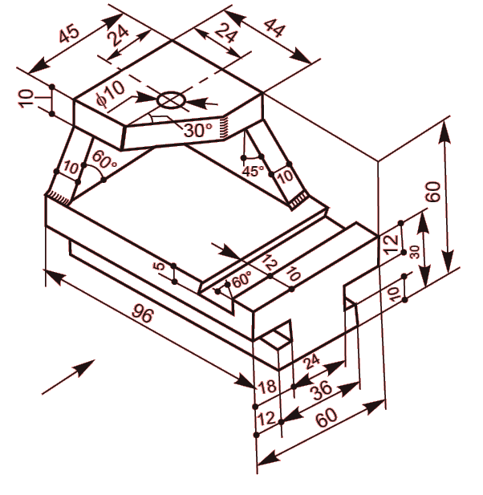

1. **Draw (i) the view from the front, (ii) the view from above and (iii) the view from the right, of the objects shown below:**

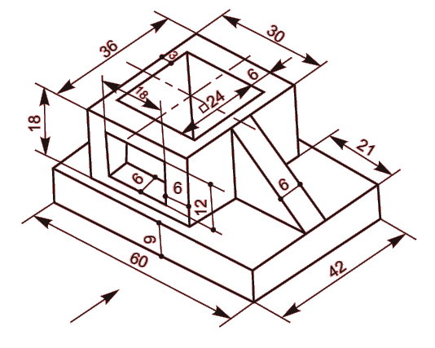

1. **Draw (i) the view from the front, (ii) the view from above and (iii) the view from the right, of the objects shown below:**

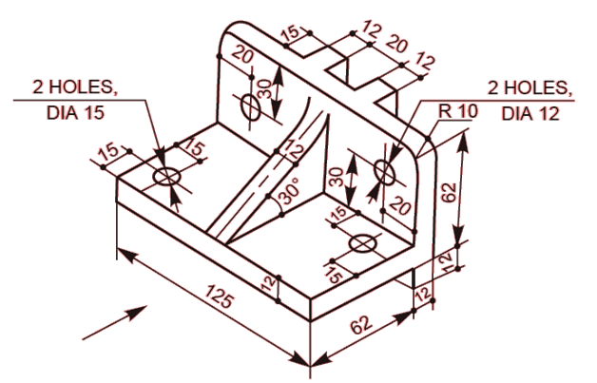

1. **Draw (i) the view from the front, (ii) the view from above and (iii) the view from the right, of the objects shown below:**

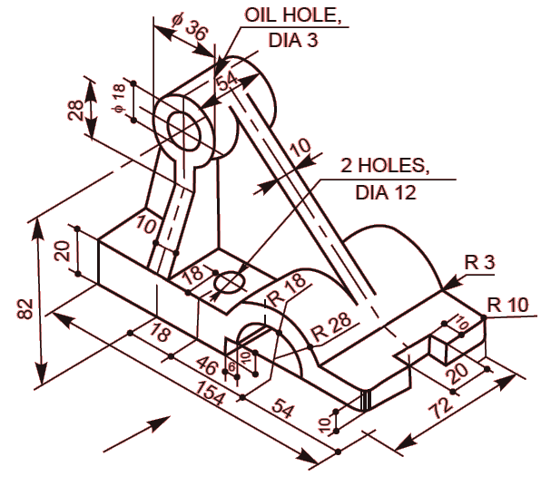

1. **Draw (i) the view from the front, (ii) the view from above and (iii) the view from the right, of the objects shown below:**

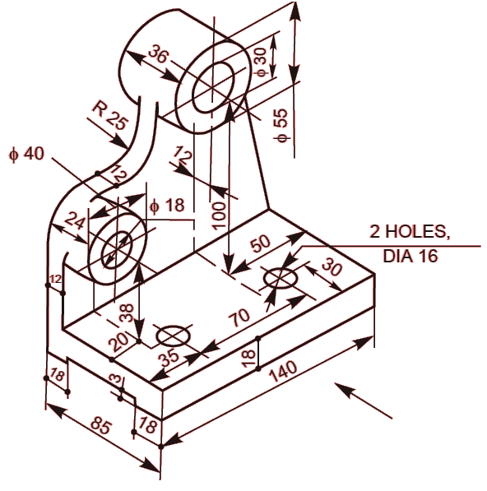

1. **Draw (i) the view from the front, (ii) the view from above and (iii) the view from the right, of the objects shown below:**

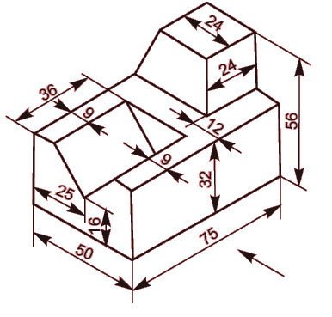

1. **Draw (i) the view from the front, (ii) the view from above and (iii) the view from the right, of the objects shown below:**

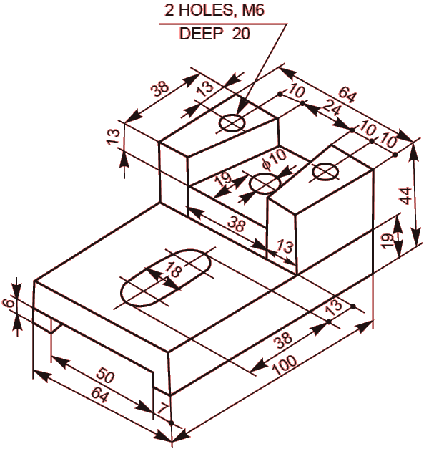

1. **Draw (i) the view from the front, (ii) the view from above and (iii) the view from the right, of the objects shown below:**

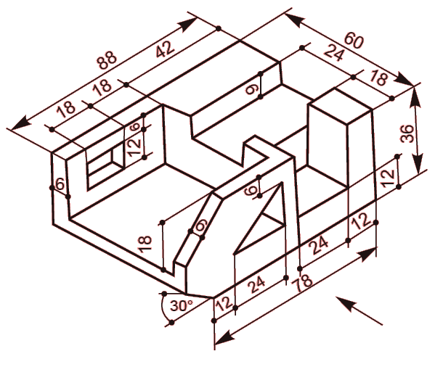

1. **Draw (i) the view from the front, (ii) the view from above and (iii) the view from the right, of the objects shown below:**

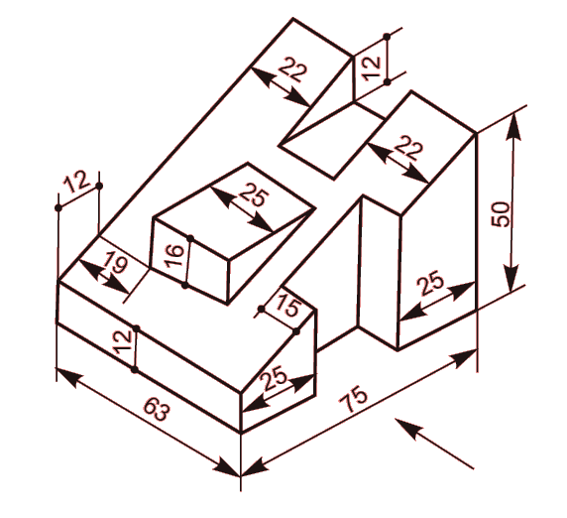

1. **Draw (i) the view from the front, (ii) the view from above and (iii) the view from the right, of the objects shown below:**

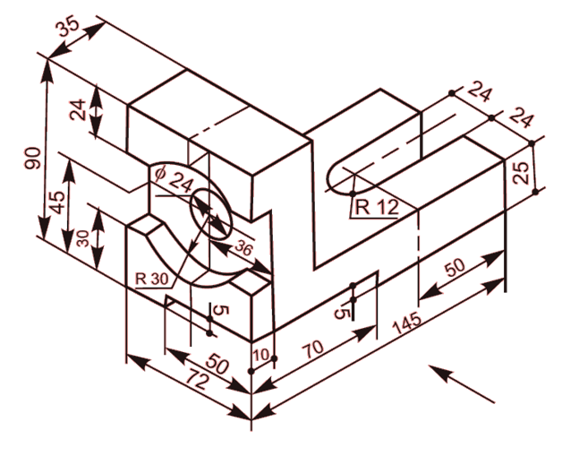

1. **Draw (i) the view from the front, (ii) the view from the right and (iii) the view from the left of the object shown below**

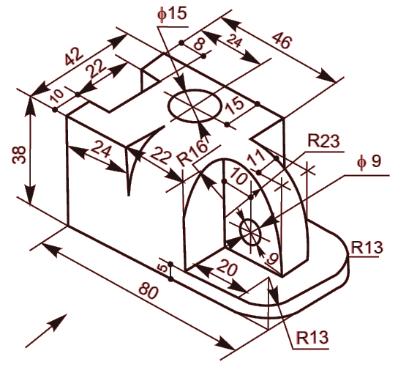

1. **Draw (i) the view from the front, (ii) the view from above and (iii) the view from the left, of the objects shown below:**

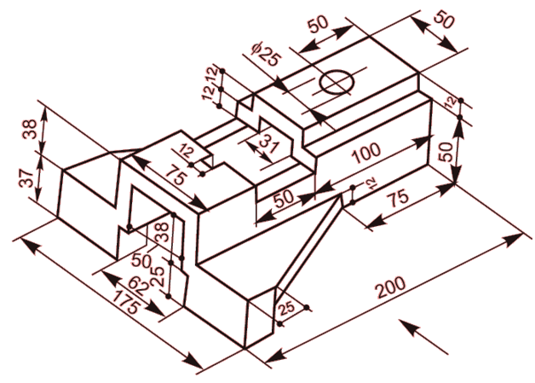

1. **Draw (i) the view from the front, (ii) the view from above and (iii) the view from the left, of the objects shown below:**

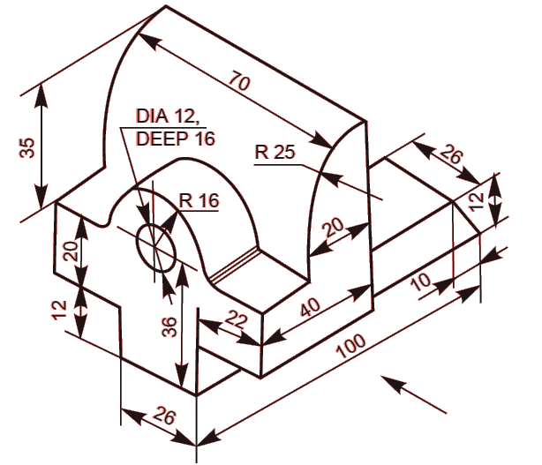

1. **Draw (i) the view from the front, (ii) the view from above and (iii) the view from the left, of the objects shown below**

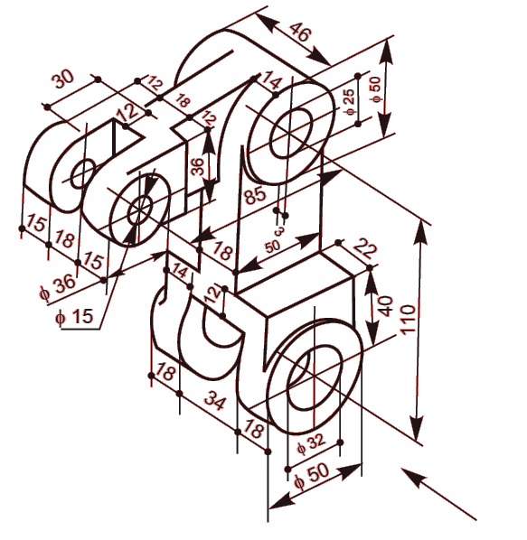

1. **Draw (i) the view from the front, (ii) the view from above and (iii) the view from the left, of the objects shown below**

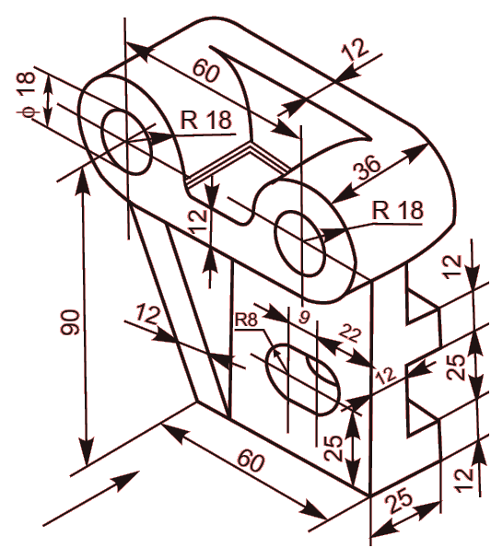

1. Draw the front view, top view and side view of the object shown in Fig

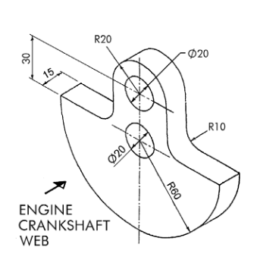

1. Draw the front view, top view and side view of the object shown in Fig

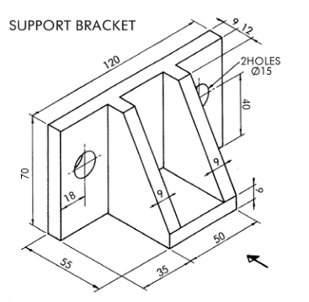

1. Draw the front view, top view and side view of the object shown in Fig

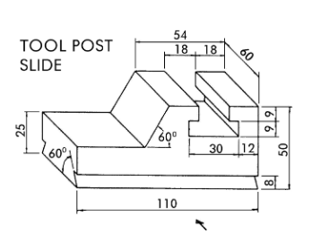

1. Draw the front view, top view and side view of the object shown in Fig

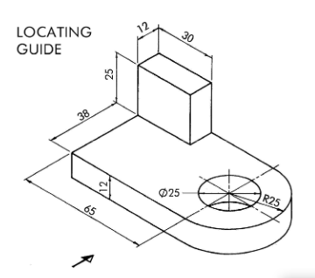

**CO1**

**PART 2**

**QUESTIONS ON 3D PRINTING:**

1. Explain about addictive manufacturing and its applications?
2. Write down different types of 3D printing technologies?
3. What is thermo plastic material and its properties?
4. Types of thermo plastic materials and their melting temperatures?
5. In detail explain various 3D printing process such as
6. FDM
7. ABS
8. SLS
9. Draw the block diagram, explaining the detail process to print a CAD model in 3D printer?

**CO2**

**PROJECT MAPPING:**

1. Explain product design and development process by using CAD/CAM approach and draw the block diagram in Draw.io project mapping software?
2. Explain Conventional design process by using CAD/CAM approach and draw the block diagram in Draw.io project mapping software?
3. Explain Conceptual design process by using CAD/CAM approach and draw the block diagram in Draw.io project mapping software?